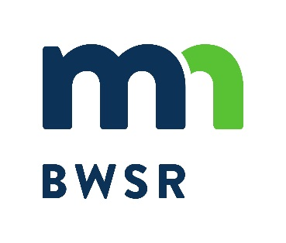
Conservation Easement
Acquisition Checklist for
Private Wetland Bank

Landowner Name: |  | County:

REQUIRED FORMS AND DOCUMENTS
SECTION 1 – Forms & Documents required for initial review by BWSR easement staff
$1,000 initial Easement Acquisition Fee (check payable to the Minnesota Board of Water and Soil Resources)
Please send check to: Wetland Bank Administration
MN Board of Water and Soil Resources
520 Lafayette Road North
St. Paul, MN 55155
Acquisition Checklist for Private Wetland Bank (this form) – Submit with Section 1 Forms & Documents
Conservation Easement Initiation Form for Private Wetland Bank
Conservation Easement Assessment Form for Private Wetland Bank
Aerial photo with preliminary easement boundary and photo scale clearly shown (no other lines/shading, etc.). Section corners or centers should also be clearly identified. This should be consistent with that provided in the approved wetland bank plan application.
Copy of Landowner's Deed(s) (Warranty, Quit Claim, Contract, Trustee, Probate or Personal Representative, etc.).
Other Ownership Documents as Applicable (Government Lot Maps, Death Certificates, Partnership Documents, Ingress/Egress Agreements, etc.)

SECTION 2 – Forms & Documents required to complete easement acquisition
*Applicants must wait to start Section 2 until after BWSR approves the Section 1 Forms & Documents
Certificate of Survey for conservation easement boundary in accordance with BWSR survey requirements.
Title Commitment
Final Title Policy
Other information/comments:

If you have questions on these requirements, please contact Lucy Dahl at lucy.dahl@state.mn.us or (651) 358-8676.

