[City and Contact Information]

Pollinator and Perennial Garden Landscaping Permit Application
For Pollinator and Native Vegetation greater than 800 square feet or greater than 25 % of parcel area, whichever is smaller

New Application Renewal
Date
Name Address Owner  Renter
Home Phone Cell Phone Fax E-mail _____________ Location of planting (if different from above) _________________________________________________
Explain Purpose/Intent of Planting _________________________________________________________
_____________________________________________________________________________________________
Project Start Date _____________
Provide the following information on the back of this form or separate sheet(s):
- Site Plan: Please sketch on reverse or attach a separate sheet to show lot lines, buildings, and location of proposed plantings. Clearly identify any corner visibility requirements and right-of-way restrictions. See example on reverse.
  - Plantings must be set back from side and rear property lines at least 3 feet.
  - The setback is not required along the street or sidewalk, or where the defined landscape abuts another similar private or public landscape area, pond, lake or stream.
- Planting Plan: Include a list of dominant plant species (Latin and/or common names) to be used. If using a planting template or plan, please attach it.
- Site Preparation and Maintenance: Identify all site preparation and maintenance steps for the project (see checklist on reverse). All noxious weeds must be removed. For prescribed burns you must obtain a permit from City Fire Marshall.
- Signage: The posting of a sign indicating that the planting is native vegetation/pollinator habitat is encouraged.
- Contact Information: If others will be performing maintenance, provide name and address of the person(s) or professional landscaping company that will be responsible for maintaining the planting.
________________________________________________________________________________
________________________________________________________________________________

Site Plan: (attach a separate sheet if needed) |  |  | Site Plan Example:  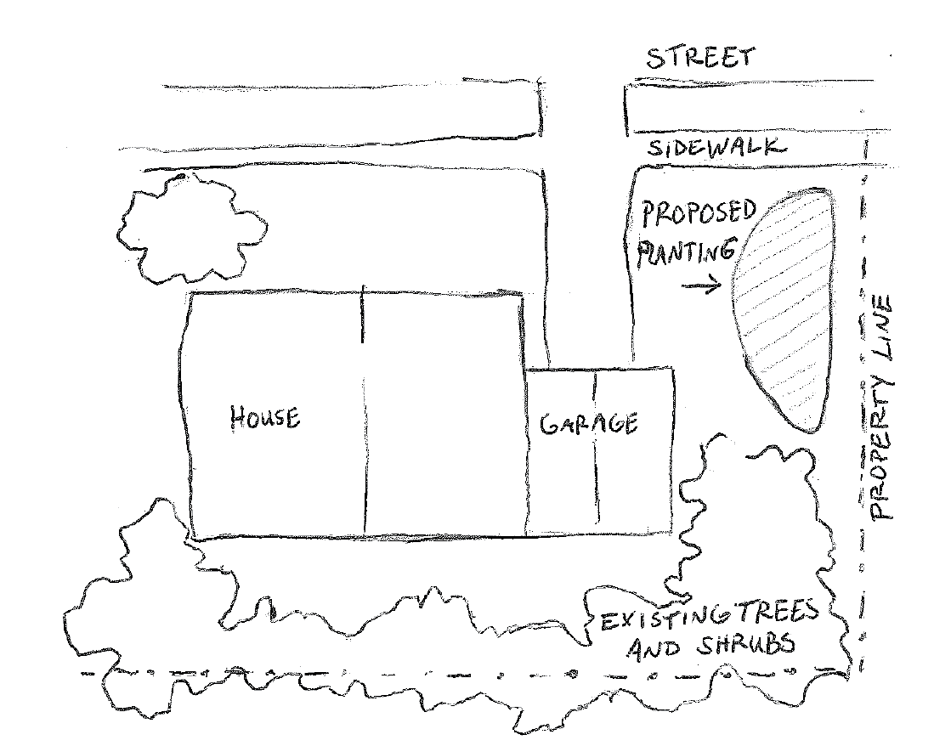
Dominant species to be planted:  ______________________________________  ______________________________________  ______________________________________  ______________________________________  ______________________________________  ______________________________________  ______________________________________  ______________________________________  ______________________________________  ______________________________________  ______________________________________  ______________________________________  ______________________________________  Attach additional sheet if necessary | Seed | Plug | Site Preparation and Maintenance Steps – select one or more using check boxes  Site Preparation Steps:  Sheet mulch  Sod removal  Other___________________________________  ________________________________________
Maintenance steps during establishment:
Weed suppression mulch/fabrics/wood mulch
Hand weeding
Clipping or mowing at 5-8 inches for seeded areas
Other___________________________________
Future maintenance steps (annual):
Replace wood mulch
Hand weeding
Clipping back vegetation after May 1 (to protect pollinators nesting in stems)
Other___________________________________

I have read and understand all applicable state statutes, city ordinances and other information included in this application packet. I certify that the information supplied in this application is correct. If granted this permit, I agree to comply with all regulations, limitations and conditions that apply to lawn maintenance in the city.

Applicant’s Signature Printed Name
□Statement of Intent □Site Plan □Plant List □Maintenance Plan □Maintenance Responsibility & Qualifications □Signed
Signed Date
Permit Denied
OFFICE USE ONLY
Permit Approved Application Checklist:

