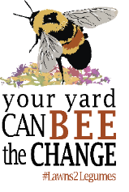
Care Guide for Lawns to Legumes Plantings
  - General Operations and Maintenance Plan
Caring for your Lawns to Legumes (L2L) project is vitally important. New plants need time to establish and care for them is critical during their first two growing seasons. Maintaining your planting will help it to flourish, be more beneficial for pollinators, and it tells others the planting is intentional which may encourage them to do their own pollinator project.
Individual Support projects must be maintained for a minimum of 3 years
Demonstration Neighborhood projects must be maintained for a minimum of 5 years
Long-term maintenance is encouraged!

This is a general guide meant to cover L2L planting care basics. Your technical assistance provider or project manager may provide more specific guidance. More info can be found on the L2L website: www.bwsr.state.mn.us/L2L
Water During the first year, plants need 1-2 inches of water per week. Place a rain gauge, can, or jar in or near your planting and supplement rainfall as needed. Additional watering may be needed during hot, dry periods. Water up until the first frost. Native plants should not need supplemental watering beyond the 2nd year unless there is a severe drought. Trees and shrubs should be watered frequently and thoroughly during their first 2 growing seasons and during times of drought. Avoid light watering as this promotes shallow root systems that are susceptible to summer heat and drought stress.
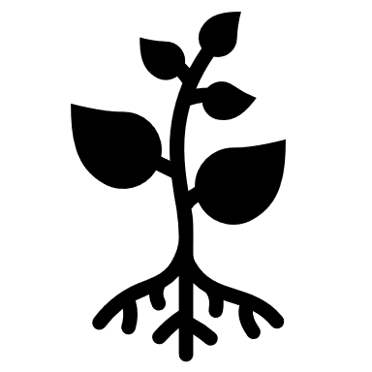
Weed Pull weeds early in the growing season and as often as needed the first two years to prevent weeds from seeding and spreading. At a minimum, weed on or around Memorial Day, Independence Day, and Labor Day. Manual methods of hand pulling, digging, and cutting are recommended. Mowing or weed whipping may be needed for Pollinator Lawns or large plantings. Pay special attention to noxious weeds such as leafy spurge, crown vetch, Canada thistle, garlic mustard, and unwanted trees, shrubs, and vines. Refer to your original planting plan to help determine what is a weed and what is not. Plant identification apps and other resources can help with plant identification. Once plants are established, they are better able to withstand some weed pressure, but continued care is important.

Tidy Up Leave all non-diseased plant material in the garden over the winter. Seed heads and stalks provide food and habitat for wildlife. Performing a Spring Clean Up for your planting is a great way to keep it from looking messy and can encourage your planting to green up (to help pollinators, wait until temperatures are consistently above 50°F). Trim stems to desired height (12-18” is recommended for pollinator habitat) and use clippings as mulch. Keep your planting free of litter and debris. If you have a sign, make sure it is in good shape to proudly display the great work you are doing for pollinators!
Created by BWSR in 2022 with assistance from Metro Blooms & Metro Blooms Design + Build & Blue Thumb
WWW.BWSR.STATE.MN.US/L2L

