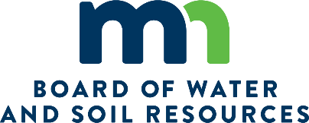 | NONSTRUCTURAL LAND MANAGEMENT PRACTICES (NLMP) IMPLENTATION PLAN REQUEST FORM  FY CONSERVATION COST SHARE BASE GRANT  (Period of July 1, through December 31, )  For The Erosion Control and Water Management Program
SWCD: Contact:

Briefly describe the District’s proposed local policy and implementation plan for incorporating nonstructural land management practices into your conservation cost share program by answering the following questions. A maximum of three pages, not including the signature page is allowed for your answers.

- What prioritized, targeted and measurable actions have been taken to insure that there is a direct erosion control and water quality connection to an identified large scale plan?

- How and what technical assistance will be provided to land occupier to insure a whole farm or field scale conservation plan is developed and implemented?

- List the types of nonstructural land management practices that will be eligible for financial assistance. What specific FOTG standards will be used for these practices? What will be the effective life of these practices?

- What will be proposed flat rates OR the maximum percentage based on invoices and receipts for the listed practices and, if flat rates are being proposed, how did you determine the feasibility of these rates? Will there be any other program funding being paid on these practices?

- How will the District implement contracts with Land Occupiers for technical assessments, conservation planning, practice implementation and technical certification, payment schedule within the timelines of the grant agreement and practice noncompliance issues?

- What are your proposed O&M procedures and policy to ensure these practices are incorporated into the farming operation? Will this result in a modified operation, maintenance and site inspection program for nonstructural land management practices as per BWSR GAM policy? And, if yes, what are those modifications.

- Is there any other information you would like to provide at this time?

SIGNATURE PAGE

Requested By:

_______________________________________ _____________________________________
SWCD Chair Signature Date

Approved By:

_______________________________________ _____________________________________
Board Conservationist Signature Date

Please submit this request to your Board Conservationist on or before the end of the first Fiscal Year of the grant.
BCs must attach a copy of the approved request form under the Attachments Tab of the grant record in eLINK.

