TREASURER’S REPORT SETUP WITHIN QUICKBOOKS
Go to Reports
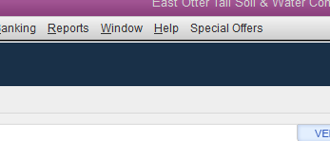
Scroll down to Company & Financial, then Balance Sheet Standard. With the Balance Sheet open place your cursor over the dollar amount of your Total Checkings/Savings and double click. A Transactions by Account window will open.
Click on the customize report.
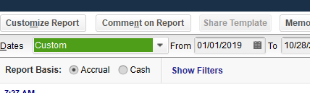

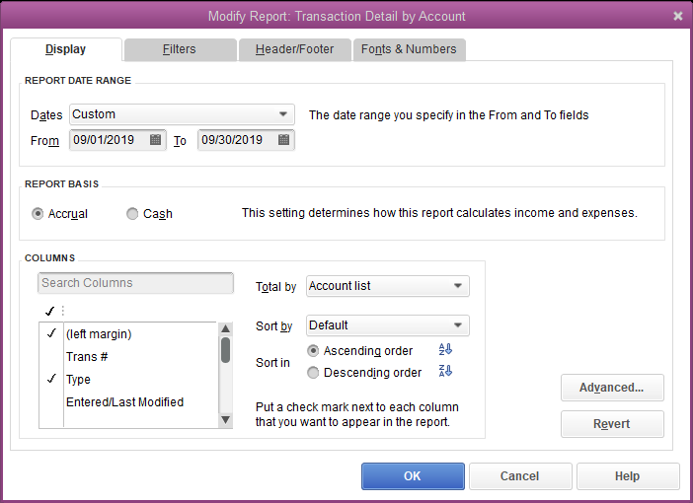
Select the Display tab. Then select items to include in the report. Suggested items are Type, Date, Num, Name, Memo, Amount, and Balance. Add or subtract the items to display. All of these items are already selected. To get rid of any unwanted items, simply click on the check mark to the left of the item. Or to select an item, click to the left of that item so that a check mark appears. Then click ok.
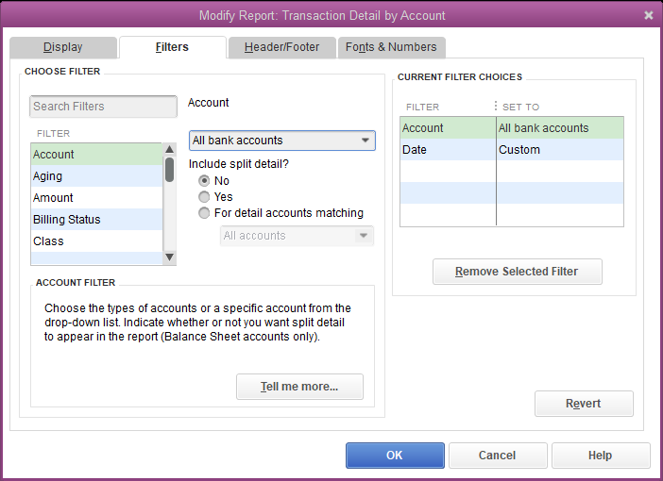
Next, add filters for what to include in the report. Click on the Filters tab. In the account section, click on the arrow to the right and select “All bank accounts.”
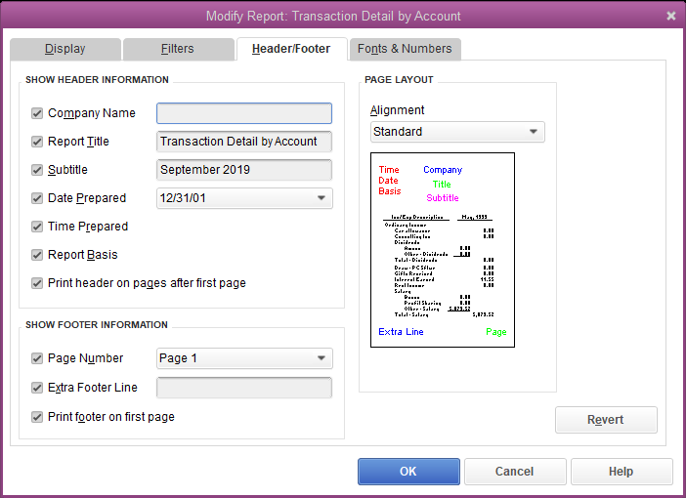
Your company name should appear at the top. For the report title, change it to “Treasurer’s Report.” Then click OK.

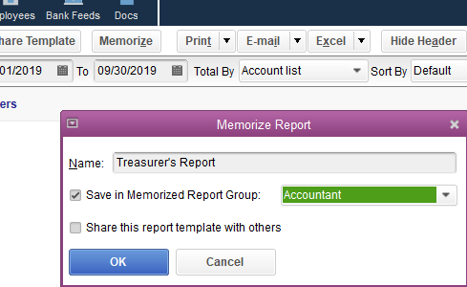
Click on the Memorize tab. When the memorize report box opens in the Save in memorized report group, make sure Accountant is selected and click OK. Then close the report just created and exit the report center.
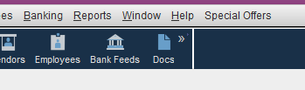
Click on Reports, hover over Memorized Reports, scroll down to Account and select Treasurer’s Report. Test it out by changing the dates. Treasurer’s Report now created!

