Native Construction General 32-242

Updated: 2023
This mix has been designed for areas with mesic soils and full sun for at least 70% of the day where rapid establishment of native vegetation is needed as part of the construction of berms, embankments and other practices; while also providing wildlife habitat, soil stabilization, and water quality benefits.

Partners also include collaboration among Non-profits, Seed vendors, SWCD, Tribal Governments, Consultants,
County and Cities. (See partner list on website)

 | 32-242 | Native Construction General Mix
Code | Common Name | Scientific Name | PLS lb/ac | % by PLS lb/ac | Seeds/ft2 | % by Seeds/ft2
andger | Big Bluestem | Andropogon gerardii | 1.60 | 4.26% | 5.88 | 7.58%
boucur | Sideoats Grama | Bouteloua curtipendula | 1.00 | 2.66% | 2.20 | 2.84%
brocil | Fringed Brome | Bromus ciliatus | 0.90 | 2.39% | 3.64 | 4.69%
elycan | Canada Wild Rye | Elymus canadensis | 2.00 | 5.32% | 3.82 | 4.93%
elytra | Slender Wheatgrass | Elymus trachycaulus | 2.00 | 5.32% | 5.07 | 6.54%
elyvir | Virginia Wild Rye | Elymus virginicus | 2.00 | 5.32% | 3.09 | 3.98%
panvir | Switchgrass | Panicum virgatum | 1.00 | 2.66% | 5.14 | 6.63%
poapal | Fowl Bluegrass | Poa palustris | 0.60 | 1.60% | 28.65 | 36.96%
sornut | Indiangrass | Sorghastrum nutans | 1.00 | 2.66% | 4.41 | 5.69%
 |  | Grasses Subtotal | 12.10 | 32.18% | 61.89 | 79.85%
chafas | Partridge Pea | Chamaecrista fasciculata | 0.27 | 0.72% | 0.27 | 0.35%
descan | Showy Tick Trefoil | Desmodium canadense | 0.07 | 0.19% | 0.14 | 0.18%
monfis | Wild Bergamot | Monarda fistulosa | 0.02 | 0.05% | 0.51 | 0.66%
rudhir | Black-eyed Susan | Rudbeckia hirta | 0.09 | 0.24% | 3.04 | 3.92%
verstr | Hoary Vervain | Verbena stricta | 0.05 | 0.13% | 0.51 | 0.66%
 |  | Forbs Subtotal | 0.50 | 1.33% | 4.48 | 5.78%
cover | Oats/Winter Wheat | Avena sativa/Triticum aestivum | 25.00 | 66.49% | 11.14 | 14.37%
 |  | Cover Crop Subtotal | 25.00 | 66.49% | 11.14 | 14.37%
 |  | Total | 37.60 | 100.00% | 77.51 | 100.00%

Native Construction General Seed Mix Guidance

Seed mix name: Native Construction 32-242
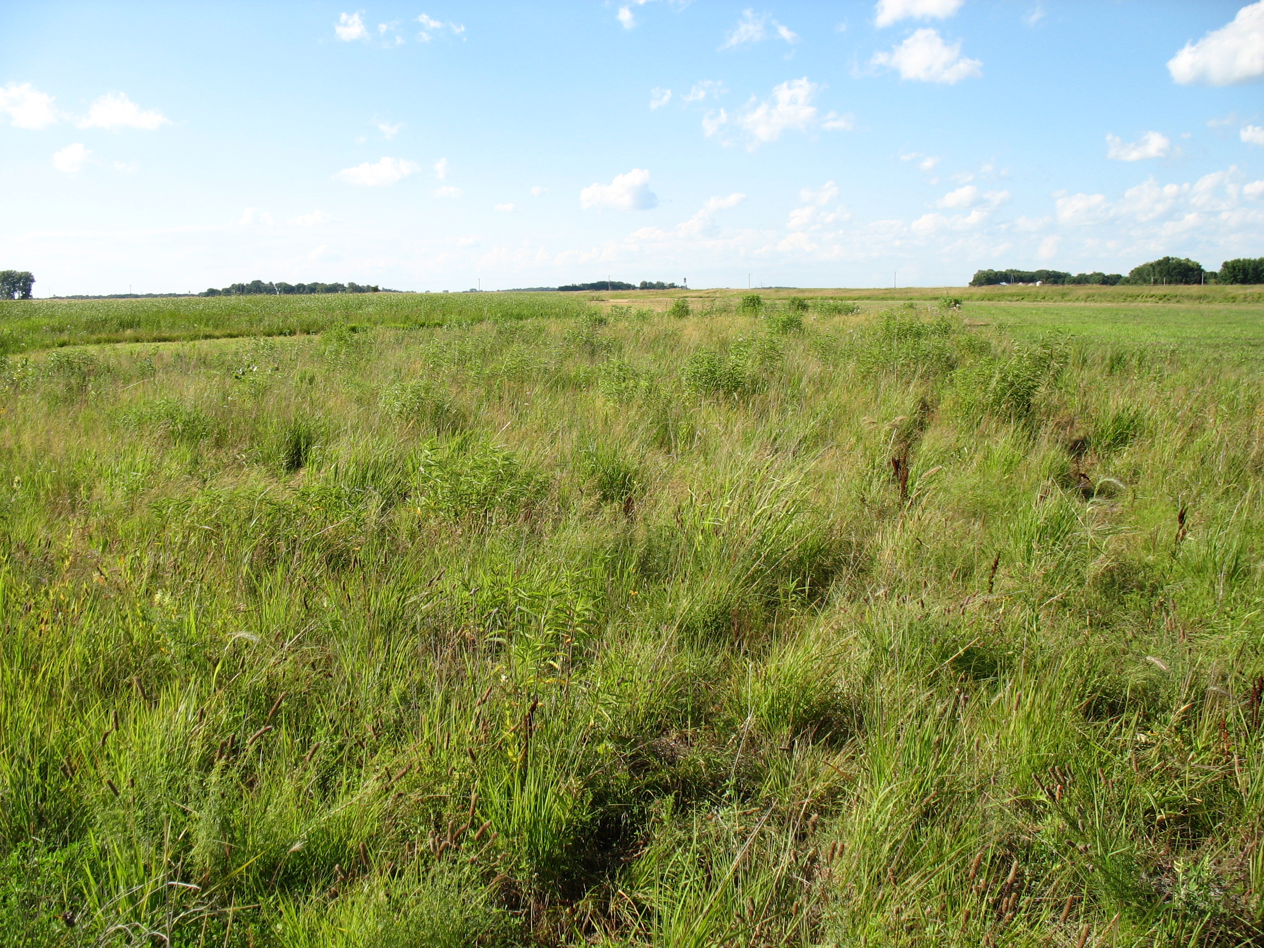
Geographic area: Statewide
Year of development:2009
Year/s of update: 2023
Status (Standard or Pilot mix): Standard
Primary and Secondary Functions:
Primary – Soil stabilization, wetland functions, and water management
Secondary – Wildlife habitat,
Similar State Mixes: 35-242 Mesic Prairie General, 35-442 Mesic Prairie Northwest, 35-542 Mesic Prairie Southwest, 35-642 Mesic Prairie Southeast,

Compatible NRCS Practice Standards: NA
Compatible Minnesota CRP Practices: NA
Suitable Site Conditions: Constructed components of restoration projects such as embankments, berms, ditch plugs and other areas of construction. The mix contains a combination of moist soil and upland species to accommodate a variety of hydrology conditions. The mix also includes a combination of early, mid and late successional species.
How to Modify for Site Conditions and Goals: This mix includes a list of additional species that can be considered to add species diversity. Site conditions such as sunlight, soils, hydrology and existing vegetation along with functional goals for the project such as carbon sequestration, pollinator habitat, and benefit to bird species can all have an influence on species selection and the modification of seed mixes. Additional plant species can also be added from containerized plants. It is also common that seed substitutions (see list) are used for wetland seed mixes when other species are not available.
Site Preparation: Primary goals for site preparation tend to focus on controlling weed species and providing ideal growing conditions for seed or plants to be installed as well as loosening compaction of construction areas to allow for suitable growing conditions. It is important this seed mix is not seeded on hard crusted areas. It is best to seed the mix shortly after construction is completed and soils are still soft and moist or after additional disking and harrowing of the soil surface to sure that good seed to soil contact is accomplished. If an area to be seeded is in perennial weeds such as smooth brome, quack grass or bluegrass and cannot be put controlled as part of other site preparation activities for larger areas intensive site preparation may be needed. Herbicide application is often recommended, as tilling alone may re-suspend the rhizomes, allowing them to continue growing. For species such as reed canary grass and giant reed grass, cropping with chemicals that break down quickly, or combinations of mowing, herbicide application, prescribed burning, and tilling (or possibly additional herbicide application) may be needed. The Minnesota Wetland Restoration Guide provides detailed management recommendations for a wide range of species.

Seeding Dates:
As this seed mix has a dominance of grasses which establish well in the spring this mix can be installed once soil temperatures reach 50 degrees Fahrenheit until June 30th. If a wetland project will be constructed in the spring/early summer or will have flowing or fluctuating water levels it may be better to seed later in the spring after water levels stabilize. The seed mixes can also be installed in the fall after October 15th as a dormant seeding. It is also common to wait until shortly before snowfall to prevent the loss of seed from wind, birds and rodents. Snow seeding is conducted during early or late winter when there is less than four inches of snow, and on sunny days when seed can move to the soil surface. This technique has been successful for a wide variety of species types. Refer to the Minnesota Wetland Restoration Guide for more information about snow seeding. Wetland construction may be conducted at other times of year requiring seeding. Mid-summer and mid fall are the two seasons that typically have the lowest success for seeding. Mid-summer can lead to poor establishment if there are drought conditions and mid fall can lead to some species germinating and the seedlings then need to survive through the winter. Early fall can sometimes be a successfully time to seed grasses, particularly if there is sufficient moisture and cooler temperatures.

Seedbed preparation
Methods that are used to prepare a seedbed can vary depending on the type of seeding equipment to be used. If a traditional native seed drill will be used, a smooth, firm seedbed is required. Sites that were recently tilled will require additional soil treatment such as harrowing and rolling to prepare an adequate seedbed and prevent seed from being buried too deep. Broadcast seeding can be conducted on soybean or corn fields, or fields that have been disked, as long as the soil is allowed to settle before seeding. Some practitioners have found that broadcast seeding on a smooth surface (not tilled or disked) leads to the establishment of higher diversity. It is important that the soil surface is not too hard packed, particularly after construction, so cultipacking or light harrowing before broadcast seeding may be needed. Seed can be lost on smooth surfaces, so it is recommended to seed into temporary cover crops or to roll sites after seeding.
Temporary Cover Crops and Mulch
The use of short-lived temporary cover crops help stabilize project sites and minimize the need for additional mulch in preparation of planting native seed mixes. They can also provide time to observe weed problems, and to allow for proper weed control before fall seeding. Temporary cover crops such as oats or winter wheat (the two species most commonly used) should be mowed to 10-12 inches before seeds mature (or harvested upon maturity) to prevent re-seeding. Slough grass (Beckmannia syzigachne) is a common cover crop for wet areas. Annual rye grass was commonly used but is generally avoided now due to its ability to inhibit germination of native species. Other cover crops typically used in agricultural fields, such as buckwheat, pennycress, and radishes, can help stabilize soil, build soil quality, or provide weed competition as part of restoration projects. Also see NRCS Agronomy Technical Note 31. Temporary cover crops can be a good option for areas of construction to meet erosion permits and allow time to manage weeds before permanent seed mixes are installed.
Seeding Methods
A variety of seeding equipment is used for seeding including broadcast seeders, traditional native seed drills, no-till drills, Brillion seeders and Trillion seeders. Specialized native seed drills can handle a wide variety of seed (fluffy, smooth, large and small) and low seeding rates and work well for seed mixes on slopes where seed to soil contact is needed and they work well for grass seed that typically does best when seeded around ¼ inch into the soil, so they are a good option for this seed mix.
Management Methods –
Establishment Mowing
Establishment mowing may be beneficial for plantings if the site conditions are not too wet for the equipment. Pressure from annual and biennial weeds is generally less with increased soil saturation and water depth. For smaller projects, brush cutters, string trimmers, or hand equipment can be used to target weeds and work around native plants. See the Minnesota Wetland Restoration Guide appendix: http://bwsr.state.mn.us/restoration/resources/documents/appendix-6a-3mowing.pdf
Mowing at least twice the first season and once the second season with a flail mower or stalk chopper (to prevent smothering plants) is often helpful to decrease competition and to provide sufficient sunlight for seedlings. Weeds should be mowed to between five and eight inches before seed is allowed to set (usually as weeds reach 12-14 inches). Mowing height should be raised as native plants establish. The timing and frequency of mowing should be planned to allow sufficient light to reach native plant seedlings and preventing weed seed production. Sites with low weed competition due to sandy soils or other factors may not need mowing.
Prescribed Burning
Prescribed burning can be beneficial for some plantings, particularly if burning was part of the historic plant community for the project. Burning can remove thatch, control invading woody and invasive plants, stimulate seed germination and new plant growth, and increase diversity in plantings. In some cases, the disturbance and increased nutrients from a burn can stimulate reed canary grass germination, so this should be considered when the species is a risk for a project. Burning is typically initiated after the third or fourth years of establishment, after native vegetation is reaching maturity. Burning is commonly conducted every three to five years. Fall and spring burns should be alternated periodically to simulate natural variation. Burn plans are needed to define the details of how the burn will be conducted, who will be involved and for contingency planning. In many cases, permits are also required. It is recommended to only burn one-half or less of a project site at a time if they are large (over 50 acres), or don’t have any adjacent refuge such as other conservation lands adjacent to the site for wildlife species. Partial burns and burns that are patchy may also benefit pollinator populations if timed correctly (when pollinators are not actively foraging, or pollinators have pupated and are mobile).
Spot Treatment of Weeds
Problematic perennial weeds that cannot be managed effectively with other methods may require spot treatment with herbicide for sufficient control. Examples include reed canary grass, quack grass, purple loosestrife, Canada thistle, and Kentucky bluegrass. In some cases, herbicide treatment is not conducted during the first or second year of establishment to avoid impact to seedlings, but it may be important to control some weeds before they have a chance to spread. A common practice for Canada thistle control involves clipping seedheads while they are in the bud stage (usually early June) and conducting herbicide application with a broad-leaf specific herbicide in the fall (mid to late October). This timing limits the application of herbicide while pollinators are active. Grass-specific herbicides are used to control reed canary grass in wet meadow restorations, particularly on sites dominated by forbs and sedges that will not be affected. Grass-specific herbicides are most effective on young reed canary plants (6-12 inches tall) than on mature plants. There is some evidence that using surfactants along with herbicides and disking prior to application may improve effectiveness. It should be noted that grass specific herbicides are not aquatically certified and should not be used near open water. When using a broad-spectrum herbicide, it is important that an aquatic safe form of glyphosate and surfactant be used near open water. When using herbicides, labels must be followed, certified applicators must conduct the treatment and Personal Protective Equipment (PPE) must be used according to label instructions. Minimize herbicide first year/spot spray year 2. Unless significant problem weeds show up.
What to Expect in Year 1: During year one of growth many native grasses, sedges, rushes and flowers will remain about one to three inches tall. Agricultural weeds such a ragweed, barnyard grass and foxtail barley may be common but not necessarily a cause for alarm. The mowing will play an important role to keep weeds managed so the native plant seedlings receive sufficient water and sunlight. The planting may have a somewhat weedy appearance this first year.
(IMAGE)
What to Expect in Year 2: During year two the native grasses and flowers may reach their mature height and some of them may flower. Mowing will still play a key role in managing weeds and allowing seedlings to grow.
(IMAGE)
What to Expect in Year 3 and Beyond: By the end of year three most of the native plants will be nearing maturity and should flower. There may be some species that are slow to establish and may not show up for several years.
Problem Solving
Poor Establishment After Year 1 – It is often difficult to determine if a seeding is successful during the first year as establishment may vary depending on weather conditions and some species may be slow to establish. It is typically best to wait until the second year to conduct any corrective actions.
Poor Establishment After Year 2 – If native plant seedlings are not establishing about every one to two feet it may be necessary to inter-seed some species into the planting.
High Annual and Biennial Weed Competition – Typically, annual and biennial weed competition is not a big problem in wet meadow plantings as they are short lived and as long as mowing is conducted before seed is set they should not add additional seed into the planting.
High Perennial Weed Competition – Dense establishment of perennial species can be a problem as it can prevent the establishment of forbs. Herbicide application may be needed to manage perennial weeds.
Low Forb Diversity After Year 3 – If grasses and sedges are establishing successfully but there is a lack of forbs it is recommended to conduct inter-seeding of additional forbs in late fall. See the Xerces Society guide for additional information about inter-seeding wildflowers.

