Emergent Wetland RIM Project Pilot 34-183
Updated: 2023

This mix has been designed for areas with soil saturation to the surface to two feet deep during a majority of the growing season and full to partial sun along ponds, wetlands or lakeshores or for wetland restoration projects where land is being converted from other uses such as agriculture or non-native grasses to a wetland restoration. This mix has been designed for RIM or CRP conservation projects. The standard Emergent Wetland 34-181 should be used for mitigation projects.

Partners also include collaboration among Non-profits, Seed vendors, SWCD, Tribal Governments, Consultants, County and Cities. (See partner list on website )

 | 34-183 | Emergent Wetland RIM Project Mix
Code | Common Name | Scientific Name | PLS lb/ac | % by PLS lb/ac | Seeds/ft2 | % by Seeds/ft2
becsyz | American Sloughgrass | Beckmannia syzigachne | 1.20 | 32.43% | 22.04 | 18.20%
glygra | American Manna Grass | Glyceria grandis | 0.18 | 4.86% | 4.63 | 3.82%
leeory | Rice Cut Grass | Leersia oryzoides | 0.12 | 3.24% | 1.50 | 1.24%
poapal | Fowl Bluegrass | Poa palustris | 0.34 | 9.19% | 16.24 | 13.41%
spapec | Prairie Cord Grass | Spartina pectinata | 0.21 | 5.68% | 0.51 | 0.42%
 |  | Grasses Subtotal | 2.05 | 55.41% | 44.91 | 37.09%
bolflu | River Bulrush | Bolboschoenus fluviatilis | 0.13 | 3.51% | 0.21 | 0.17%
carcom | Bottlebrush Sedge | Carex comosa | 0.09 | 2.43% | 0.99 | 0.82%
carlac | Lake Sedge | Carex lacustris | 0.02 | 0.54% | 0.08 | 0.07%
carstr | Tussock Sedge | Carex stricta | 0.02 | 0.54% | 0.39 | 0.32%
elepal | Common Spikerush | Eleocharis palustris | 0.03 | 0.81% | 0.56 | 0.46%
juntor | Torrey's Rush | Juncus torreyi | 0.03 | 0.81% | 17.63 | 14.56%
schtab | Softstem Bulrush | Schoenoplectus tabernaemontani | 0.16 | 4.32% | 1.82 | 1.50%
sciatr | Dark Green Bulrush | Scirpus atrovirens | 0.13 | 3.51% | 21.97 | 18.14%
scicyp | Woolgrass | Scirpus cyperinus | 0.04 | 1.08% | 24.98 | 20.63%
 |  | Sedges & Rushes Subtotal | 0.65 | 17.57% | 68.62 | 56.67%
acoame | Sweet Flag | Acorus americanus | 0.12 | 3.24% | 0.29 | 0.24%
alitri | Northern Water Plantain | Alisma triviale | 0.12 | 3.24% | 2.91 | 2.40%
ascinc | Swamp Milkweed | Asclepias incarnata | 0.17 | 4.59% | 0.30 | 0.25%
bidcer | Nodding Bur Marigold | Bidens cernua | 0.08 | 2.16% | 0.62 | 0.51%
iriver | Northern Blue Flag Iris | Iris versicolor | 0.10 | 2.70% | 0.05 | 0.04%
saglat | Common Arrowhead | Sagittaria latifolia | 0.11 | 2.97% | 2.46 | 2.04%
spaeur | Giant Bur Reed | Sparganium eurycarpum | 0.27 | 7.30% | 0.05 | 0.04%
sympun | Swamp Aster | Symphyotrichum puniceum | 0.03 | 0.81% | 0.88 | 0.73%
 |  | Forbs Subtotal | 1.00 | 27.03% | 7.56 | 6.24%
 |  | Total | 3.70 | 100.00% | 121.09 | 100.00%

Seed Mix Enhancements or Substitutions

List of Additional Species to Add Diversity or for Substitutions

The numbers (1-9) are species ranges that relate to the MN Ecological Subsections

Emergent Wetland RIM Project Pilot
Updated 05-03-2020

Grasses:
Scientific Name | Common Name | Recommended Seeds per Square Foot
Calamagrostis stricta (2,5,8,9) | Narrow Reedgrass | 1

Forbs:
Scientific Name | Common Name | Recommended Seeds per Square Foot
Chelone glabra (1,3,5‐8) | White Turtlehead | 2
Lobelia cardinalis | Cardinal Flower | 2
Lobelia spicata | Rough‐spiked Lobelia | 2
Lysimachia ciliata | Fringed Loosestrife | 1
Physostegia virginiana | Obedient Plant | 1

Sedges:
Scientific Name | Common Name | Recommended Seeds per Square Foot
Carex bebbii | Bebb's Sedge | .2
Carex brevoir | Short Sedge | .2
Carex crinita | Fringed Sedge | .2
Carex emoryi | Emory’s Sedge | .2
Carex haydenii | Hayden’s Sedge | .2
Carex hystericina | Porcupine Sedge | .2
Carex pellita | Wooly Sedge | .2
Juncus dudleyi | Dudley's Rush | 5
Juncus effusus (1,2,5‐7) | Soft Rush | 5

Emergent Wetland RIM Project Pilot Seed Mix Fact Sheet

Seed mix name: Emergent Wetland RIM Project Pilot 34-183
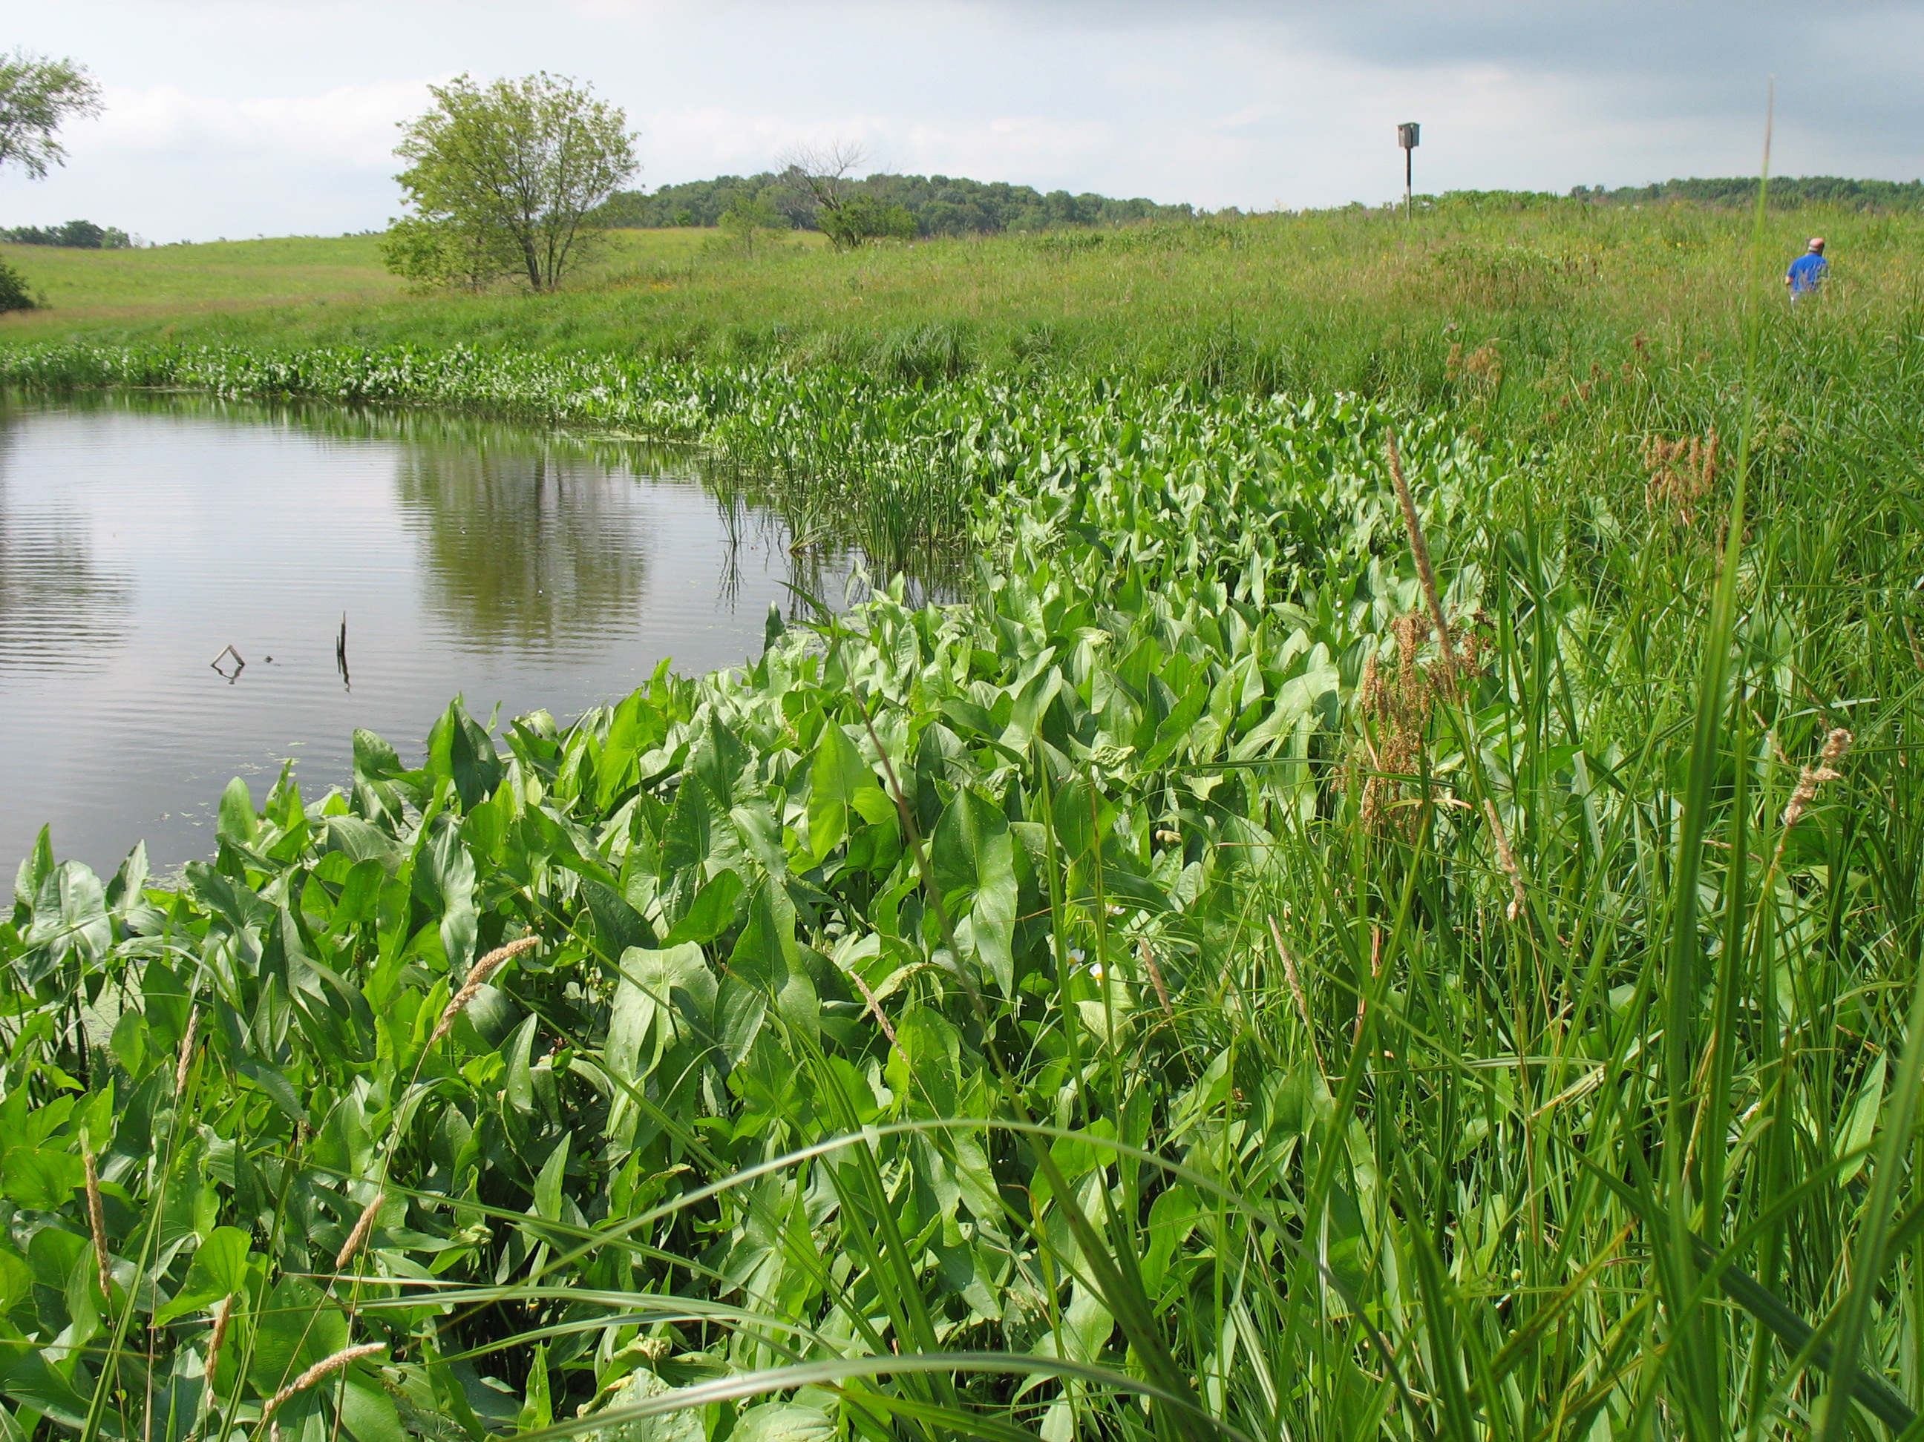
Geographic area: Statewide
Year of development:2021
Year/s of update:
Status (Standard or Pilot mix): Pilot
Primary and Secondary Functions:
Primary – Wildlife habitat, restoration of wetland functions, and water management
Secondary – Carbon Sequestration, emission reductions, pollinator habitat, songbird habitat
Similar State Mixes: Emergent Wetland 34-181
Compatible NRCS Practice Standards: NA
Compatible Minnesota CRP Practices: NA
Suitable Site Conditions: Areas with soil saturation to the surface to two feet deep during a majority of the growing season and full to partial sun along ponds, wetlands or lakeshores or for wetland restoration projects where land is being converted from other uses such as agriculture or non-native grasses to a wetland restoration.
How to Modify for Site Conditions and Goals: This mix includes a list of additional species that can be considered to add species diversity. Site conditions such as sunlight, soils, hydrology and existing vegetation along with functional goals for the project such as pollinator habitat, and benefit to bird species can all have an influence on species selection and the modification of seed mixes. Additional plant species can also be added from containerized plants. It is also common that seed substitutions (see list) are used for wetland seed mixes when other species are not available.
Site Preparation: Primary goals for site preparation tend to focus on controlling weed species and providing ideal growing conditions for seed or plants to be installed. Site preparation methods vary depending on past uses of the site and the weed species that are present. The protection of microorganism populations and native seedbanks, preventing soil erosion, and managing weed establishment are all considerations during the site preparation process. In most cases, non-herbicide methods are preferred over herbicide intensive methods to protect aquatic organisms and soil microfauna, but aquatically approved herbicides may be the most efficient method of controlling some invasive perennial species. It is common for many wetland restoration plantings to transition from corn or soybean production. Fields that are in agriculture often have control of most weeds. Another consideration is that several chemicals being used for weed control, along with herbicides (for herbicide-resistant crops) act as pre-emergents or post-emergents (designed to inhibit germination) and can be a problem for native vegetation establishment from seed. Investigate prior chemical use and labels to help define probability of having chemical carryover that could/should be addressed by using temporary cover crops to allow time for chemicals to break down. If a site is in reed canary grass, quack grass or bluegrass and cannot be put into agricultural production for one or two seasons intensive site preparation may be needed. Aquatically certified herbicide application is often recommended, as tilling alone may re-suspend the rhizomes, allowing them to continue growing. For species such as reed canary grass and giant reed grass, cropping with chemicals that break down quickly, or combinations of mowing, herbicide application, prescribed burning, and tilling (or possibly additional herbicide application) may be needed. The Minnesota Wetland Restoration Guide provides detailed management recommendations for a wide range of species.

Seeding Dates:
Wetland seed mixes are most often installed in the fall after October 15th as a dormant seeding as most sedges, rushes and forbs need a winter to break their seed dormancy and start growing. It is also common to wait until shortly before snowfall to prevent the loss of seed from wind, birds and rodents. Snow seeding is conducted during early or late winter when there is less than four inches of snow, and on sunny days when seed can move to the soil surface. This technique has been successful for a wide variety of species types. Refer to the Minnesota Wetland Restoration Guide for more information about snow seeding. Wet meadow seed can also be installed in the spring once soil temperatures reach 50 degrees Fahrenheit until June 30th but only a portion of the seed mix will germinate that first year. If a wetland project will be constructed in the spring/early summer or will have flowing or fluctuating water levels it may be better to seed later in the spring after water levels stabilize. In general, emergent seed mixes are most successful when seeded into exposed mud as some of the species float and will move if seeded into open water. As a result, it is common to keep restored or natural wetland water levels down for about one season if there is a water control structure. Once the seedlings reach about eight inches tall water levels can be raised several inches. Seedlings are susceptible to drowning so the ultimate goal is to prevent them from being under water for extended periods of time during the growing season.

Seedbed Preparation and Seeding Methods
Broadcast seeding is the preferred seeding method for emergent seed mixes as the seeds of many species are tiny and will not germinate if buried under the soil. Broadcast seeding can be conducted on soybean or corn fields, or fields that have been disked. For fields that are disked it is best to allow the soil to settle before seeding. Some practitioners have found that broadcast seeding on a smooth surface (not tilled or disked) leads to the establishment of higher diversity. It is important that the soil surface is not too hard packed, so cultipacking or light harrowing of crop fields before broadcast seeding may be needed. Seed can be lost on smooth surfaces, so it is beneficial to seed into temporary cover crops or to roll sites after seeding.
Temporary Cover Crops and Mulch
The use of short-lived temporary cover crops help stabilize project sites and minimize the need for additional mulch in preparation of planting native seed mixes. They can also provide time to observe weed problems, and to allow for proper weed control before fall seeding. Temporary cover crops such as oats or winter wheat (the two species most commonly used) should be mowed to 10-12 inches before seeds mature (or harvested upon maturity) to prevent re-seeding. Slough grass (Beckmannia syzigachne) is a common cover crop for wet areas. Annual rye grass was commonly used but is generally avoided now due to its ability to inhibit germination of native species. Other cover crops typically used in agricultural fields, such as buckwheat, pennycress, and radishes, can help stabilize soil, build soil quality, or provide weed competition as part of restoration projects. Also see NRCS Agronomy Technical Note 31.
Management Methods –
Establishment Mowing
Establishment mowing may be beneficial for wetland plantings if the site conditions are not too wet for the equipment. Pressure from annual and biennial weeds is generally less with increased soil saturation and water depth. For smaller projects, brush cutters, string trimmers, or hand equipment can be used to target weeds and work around native plants. See the Minnesota Wetland Restoration Guide appendix: http://bwsr.state.mn.us/restoration/resources/documents/appendix-6a-3mowing.pdf
If seeding can be conducted weeds should be mowed to between five and eight inches before seed is allowed to set (usually as weeds reach 12-14 inches). Mowing height should be raised as native plants establish. The timing and frequency of mowing should be planned to allow sufficient light to reach native plant seedlings and preventing weed seed production. Sites with low weed competition due to sandy soils, high moisture or other factors may not need mowing.
Spot Pulling or Treatment of Weeds
Problematic perennial weeds that cannot be managed effectively with other methods may require spot pulling or treatment with herbicide for sufficient control. Examples include reed canary grass, non-native cattails, purple loosestrife, undesirable woody vegetation, Canada thistle, and Kentucky bluegrass. Hand pulling for species such as cattails, woody vegetation and purple loosestrife is most effective when plants are small and do not have extensive root systems. In some cases, herbicide treatment is not conducted during the first or second year of establishment to avoid impact to seedlings, but it may be important to control some weeds before they have a chance to spread. A common practice for Canada thistle control involves clipping seedheads while they are in the bud stage (usually early June) and conducting herbicide application with a broad-leaf specific herbicide in the fall (mid to late October). This timing limits the application of herbicide while pollinators are active. When using a broad-spectrum herbicide, it is important that an aquatic safe form of herbicide and surfactants be used near open water. When using herbicides, labels must be followed, certified applicators must conduct the treatment and Personal Protective Equipment (PPE) must be used according to label instructions. Minimize herbicide first year/spot spray year 2. Unless significant problem weeds show up.
What to Expect in Year 1: During year one of growth many native grasses, sedges, rushes and flowers will remain about one to three inches tall. Agricultural weeds such a ragweed, barnyard grass and foxtail barley may be common but not necessarily a cause for alarm. Mowing/trimming may be helpful to keep weeds managed so the native plant seedlings receive sufficient water and sunlight. The planting may have a somewhat weedy appearance this first year.
(IMAGE)
What to Expect in Year 2: During year two the native sedges, rushes, grasses and flowers may reach their mature height and some of them may flower.
(IMAGE)
What to Expect in Year 3 and Beyond: By the end of year three most of the native plants will be nearing maturity and should flower. There may be some species that are slow to establish and may not show up for several years.
Problem Solving
Poor Establishment After Year 1 – It is often difficult to determine if a seeding is successful during the first year as establishment may vary depending on weather conditions and some species may be slow to establish. It is typically best to wait until the second year to conduct any corrective actions.
Poor Establishment After Year 2 – If native plant seedlings are not establishing about every one to two feet it may be necessary to inter-seed some species into the planting.
High Annual and Biennial Weed Competition – Typically, annual and biennial weed competition is not a big problem in emergent wetland plantings as they are short lived and as long as mowing is conducted before seed is set, they should not add additional seed into the planting.
High Perennial Weed Competition – Dense establishment of perennial species can be a problem as it can prevent the establishment of native vegetation. Herbicide application may be needed to manage perennial weeds.
Low Forb Diversity After Year 3 – If grasses and sedges are establishing successfully but there is a lack of forbs it is recommended to conduct inter-seeding of additional forbs in late fall. See the Xerces Society guide for additional information about inter-seeding wildflowers.

